A RESEARCH STUDY
EFFECT OF ANAPANASATI MEDITATION
ANXIETY, DEPRESSION AND VERBAL AGGRESSION

BY
B. SIVARAMAPPA
PSS Academy,Bengaluru.

THE RESEARCH WAS CONDUCTED UNDER THE GUIDANCE OF
DR. H.R.NAGENDRA DR. SUDHEERA DESHPANDE
SVYASA
BY B.SIVARAMAPPA
PYRAMID VALLEY & PSS ACADEMY

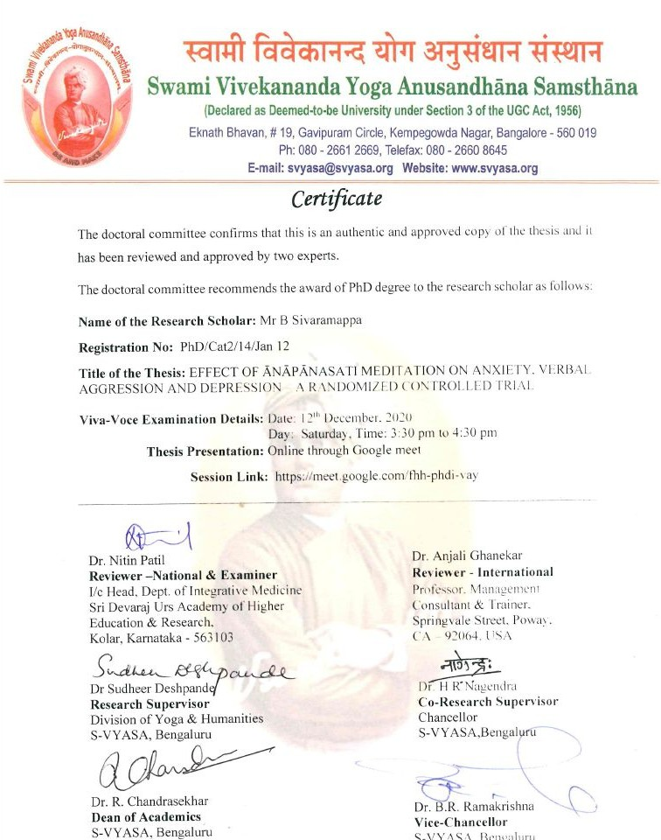

AIM
To Bring Evidential Facts About Anapanasati Meditation And Its Effect On Aggression, Anxiety And
Depression

Literary Survey Books Reviewed:
Patañjali Yoga Sūtrās - Bhagavadgīta Zen Meditation -Aśtāvakragītā Yogavāśiṣṭa - Brahma Sūtrās Ānāpānasati Meditation -Dhammapāda

SCIENTIFIC SURVEY
(MEDSKER, FORNO, SIMHAN, JUAN, & SCIENCES, 2016).
(CAHN & POLICH, 2006) (GOLEMAN & DANIEL, 2010) (WENK & SORMAZ, 2010) ETC ETC ON MINDFUL MEDITATION

METHODOLOGY RANDOMISED CONTROL STUDY

SAMPLE
EXPERIMENT: 59 INDIVIDUALS CONTROL : 60 INDIVIDUALS
FROM PYRAMID KENDRAS VISITING PYRAMID VALLEY INTERNATIONAL AND PSSA UNIT

INTERVENTION
ANAPANASATI ONE HOUR A DAY 6 MONTHS

SCALES USED
- STATE-TRAIT ANXIETY INVENTORY (STAI)
- VERBAL AGGRESSIVENESS SCALE (VAS)
- BECK DEPRESSION INVENTORY-II (BDI)

RESULTS

A RESEARCH ON ANAPANASAATI MEDITATION- TABLE 14: PRE AND POST SCORES OF STAI, VAS, BDI PRE/POST EXPERIMENTAL CONTROL
ALL PARTICIPANTS (N = 59) (N=60) DEPRESSION
BDI PRE 25.78 ± DROP BY 84,40% 15.33 ± 11.43
BDI POST 4.02 ± 5.33 16.60 ± 12.77

VERBAL AGGRESSION
VAS PRE 66.53 ± 6.93 DROP BY 29.40% 66.73 ± 12.15
VAS POST 46.97 ± 6.79 64.97 ± 13.16
ANXIETY
STA PRE 47.61 ± 7.41 DROP BY 6.36% 50.55± 4.25
STAI POST 44.58 ± 5.08 52.02± 4.41

THIS RESEARCH SHOWS THAT LEVELS OF AGGRESSION, DEPRESSION AND ANXIETY CAN BE BROUGHT DOWN SIGNIFICANTLY BY ANAPANASATI MEDITATION

THANK YOU…..
B. SIVARAMAPPA

